Agun Ki, The House of Hope

Nagaland is a state in the far North East of India. It is a mountainous and remote region, with poor infrastructure and has a population whose welfare has been neglected. Tening town lies in the South of the state and is the centre of one of the poorest and remotest areas in the region.

Map of Nagaland

The people in the area surrounding Tening are very poor and rely mainly on subsistence farming to survive. Adults spend most of their days tending the fields which leaves the children to their own devices much of the time.

State education is virtually non-existent in the area and there is minimal health care. Adults often die early or abandon their children, in search of work in the city. This means that there are many children without parents, fending for themselves, with some even being sold into servitude in the cities of India.

Farming on the Hillside

The issue of neglected children is one of many in the Tening area and a grassroots NGO, NARUDA, has been set up to overcome the problems of the people. Other initiatives that NARUDA is tackling include:

- Enabling single mothers and widows to start craft businesses so that they may provide for their families
- Installing drinking water facilities in local villages
- Providing off-grid power for remote villages, where electricity is not available
- Teaching local villagers about improving yield for their crops and changing crops to provide sustainable income
- Introducing livestock farming programmes

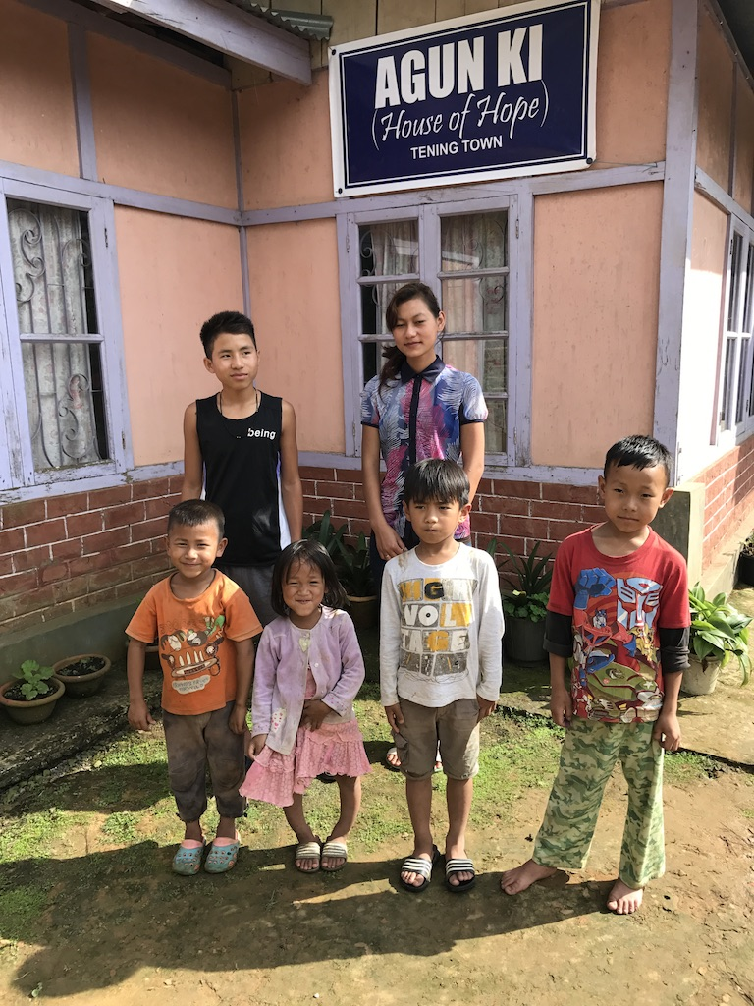
Agun Ki, the House of Hope, was established by a local church minister and his family in their home to look after some of the most needy, local children.

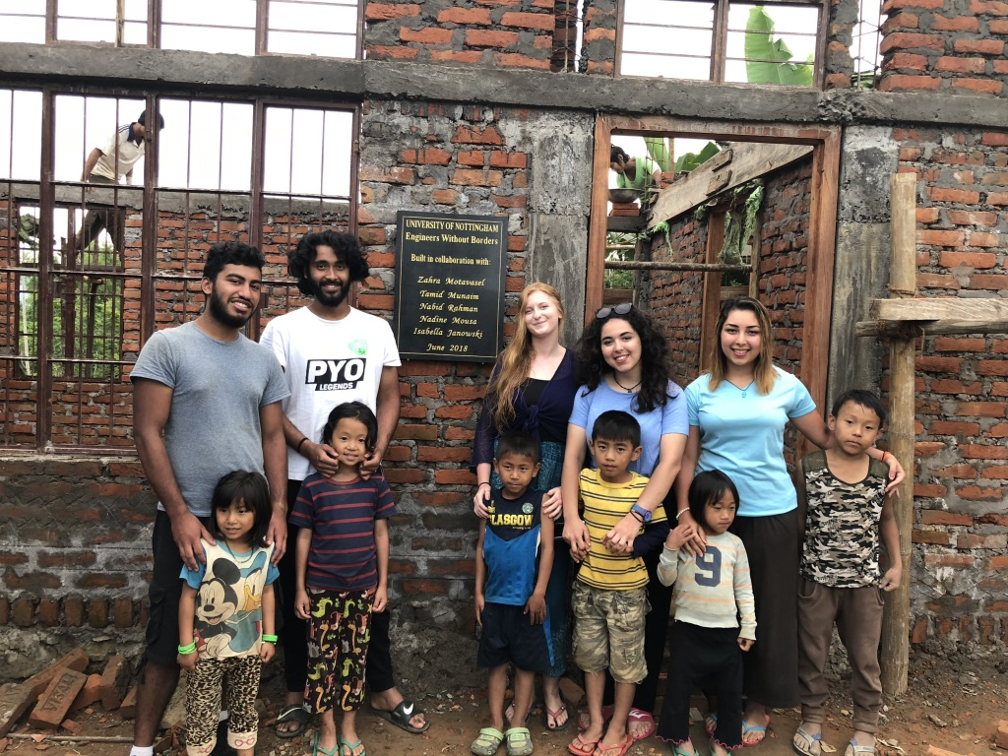
The extension to Agun Ki in construction
After he retired with no pension, he used his dwindling reserves to pay for the children’s education and upkeep. In 2016, Agun Ki was incorporated into NARUDA, a newly formed NGO and a partnership with a Scottish based charity, Afri-link, was formed.
The original Agun Ki

This partnership funded an extension to Agun Ki, built with the help of volunteers in 2018, which now allows NARUDA to take in an extra 8 children. What is needed now is to furnish and equip the extension, to continue with support for the current children and to find funds to look after the additional children we can now accommodate.

The costs to support the children are tabulated below:

 | Cost per month per child | Annual cost per child
School fees, uniforms and text books | £15 | £180
Clothes, food and medical expenses | £15 | £180

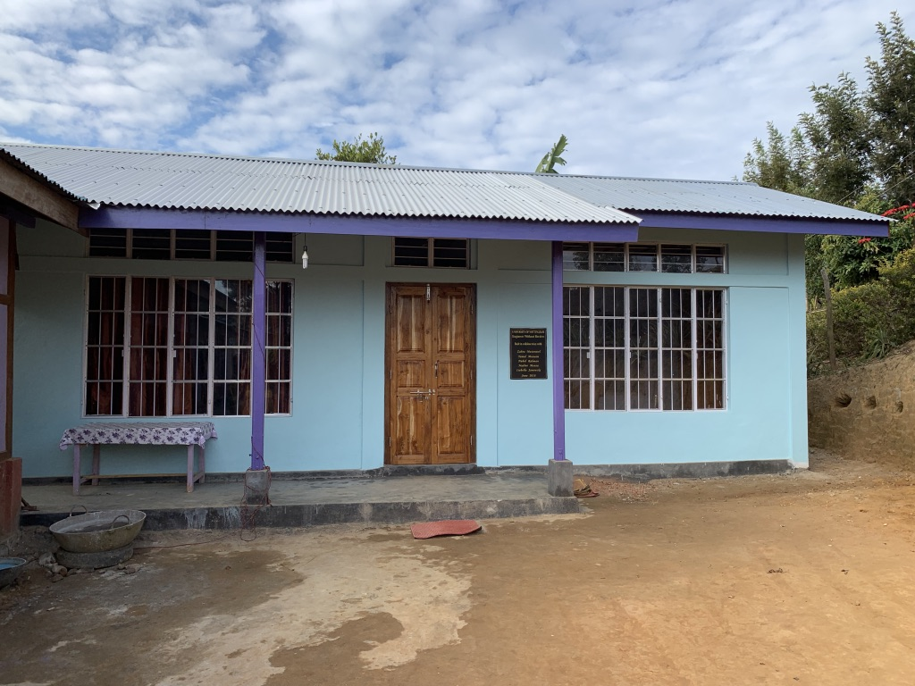
The completed extension at Agun Ki
The funds needed to furnish the extension are shown below:

 | Unit cost | Cost for eight children
Bunk bed | £70 | £280
Study table | £40 | £80
Chair | £6 | £48
Mattress | £30 | £240
Blanket | £10 | £80
Pillow | £5 | £40
Bed sheet | £5 | £40
Pillow cover | £2 | £16

If you are interested in helping with furnishing Agun Ki or supporting a child, please get in touch with John Pepper at info@naruda.net

