Project Proposal
REAL DREAM HOME: A RESIDENTIAL EDUCATIONAL TRAINING CENTER/PREPARATORY SCHOOL
REAL Nepal, PO BOX 03,
Panauti, Kavrepalanchok, Nepal

Proposal for
A Scholarship for 15 blind children for school equipment, computer lab installation, educational materials and daily needs.

Rajendra Prasad Dhital
Project Manager of REAL Nepal

March, 2019
Implementing Project: | REAL Dream Home, a residential training center/preparatory school
Project Title | Computer lab installation & regular class run
Applicant Name | REAL Nepal  P.O. Box 03, Kavrepalanchok , Nepal  Cell-phone: +977-9841640967  E-mail: rajendra2016@iiseconnect.org  Website: www.real-nepal.org
Project location: | Panauti Municipality-04,Kavrepalanchok,Nepal
Project duration: | One year ( April 2019 to, March 2020)
Project Goal | To re-awaken a sense of pride in Education and enable children with blindness and visual impairment complete access to education even if there is less support to them by leaders and community members.
Responsibility: | Mr.Rajendra Prasad Dhital, project manager of REAL Nepal  Contact: : rajendra2016@iiseconnect.org or rajendra.realnepal@gmail.com  Cell-Phone:+977-9841640967
Total Budget | 3037650  NPR,or,  26688.19  US$
Amount Requested From | 3037650  NPR,or,  26688.19  US$
Other Contributions | Looking for
Project Commencement | On-going

Table of Contents
EXECUTIVE SUMMARY 1.0
BACKGROUND 2.0
PERSONAL PROFILE 3.0
REAL Nepal – Understanding the Problem 4.0
Vision, Mission, Objective and Goal 5.0
REAL NEPAL- Understanding How We Can Change Nepal 5.1
Project Sustainability 6.0
Project Debrief 7.0
Outcomes 7.1
Budget Description 7.2
Curriculum 8.0
Key terminology 9.0

1.0 EXECUTIVE SUMMARY
Life has no meaning for most blind children in rural Nepal! REAL Nepal wants to help them by creating a “Residential preparatory school and training centre”. This is to promote social inclusion and provide special services for blind children in Kavre district and all over Nepal. The needs and struggles are obvious: inaccessible landscapes due to remoteness and backwardness, poverty, discrimination and lack of reliable policies. (See problem definition, section 4.0)

Bed Kumari Raya, a 5 year old blind girl child from Mechchhe 6, Kavre has never been out of her home. She has never been to school and doesn’t talk to people outside her family. Along with her, there are other two members who are also blind in her family. They are her mother and youngest brother. But she shows great interest in going to school.
We want to help children like her, to realize their dreams.
To provide training, Braille education, computer skill, daily living-and mobility-skills for 15 children for one year from March 1 2019 to February 31 2020, We would need approximately NRP 3037650 /US$ 26688.19

. Please see further details in Section7.2)

2.0 BACKGROUND
REAL Nepal is a non-profit, social organization which is registered at district administration office Dhulikhel. The project is located in Panauti Municipality ward No. 4, Taukhal, Kavre district, Nepal which is a rural hilly region. It was established to address the problems of blind children and aims to ensure their right to education and self-independence.
In Nepal, some of the major causes of blindness are: lack of proper health during pregnancy, lack of awareness about eye care, disaster, accidents and diseases. According to the recent report of the District coordination committee Kavre survey, after the 2015 earthquake, 587 blind children live in this area, including those who had become blind through the earthquake.
This is the record of only one district. There are many districts in Nepal like Kavre district.
Within the community, blind people are subject to severe discrimination in terms of access to education, sports, mobility, basic information and technology and there is no support for establishing their own family. Moreover, there is a large number of school drop outs among blind children, even in the primary level. These barriers are hindering for filling an active participation of blind and visually impaired people in society.

3.0 PERSONAL PROFILE
One day, as a ten year old child walking back from school, I fell down. I was crying because I had scratched my new shoes and was scared that my father could scold me. That happened because of my blindness. I couldn’t walk properly up down the hill path. At university, I requested many people to help me to filli in exam forms. They did not believe that I was blind and refused. At an interview for a project coordinator, they appreciated my involvement with the disability sector but they did not give me the job, because they ‘assumed’ I could not maintain a database and organize my files. Despite the fact that I assured them that I could, they wouldn't let me try. Sometimes my friends used to say things about me in front of me, as though I was not present.

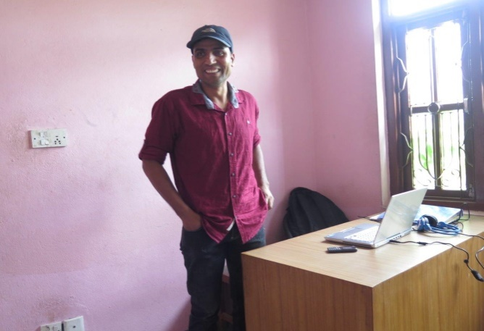
My name is Rajendra Prasad Dhital, I was born visually impaired and come from Kavre District in Nepal. This is an economically, literally and socially backward region which lacks public access facilities for the blind. At the age of eight, I used to walk two hours through narrow paths in hilly terrain to attend a mainstream school. Because I had limited vision, I could read and write only by holding the book very close to my eyes. While other normal children were playing or participating in recreational activities, my class teacher used to send me back home. Ignoring these challenges and obstacles, I passed my school level and left to Kathmandu for further education. During 2008, my vision decreased suddenly. I was almost blind. I became unable to walk and read independently though I still had some light perception.

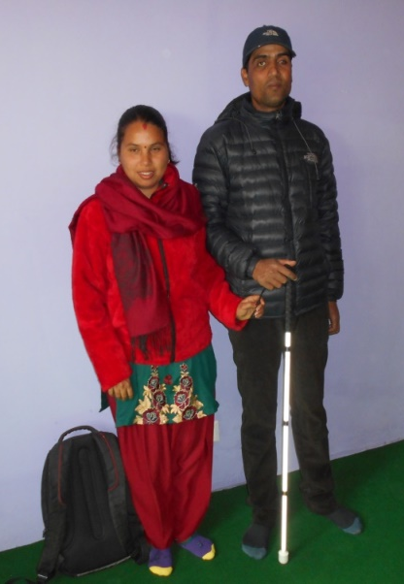
I thought there were no options in life and felt like committing suicide. My friends encouraged me to get rehabilitation by the Nepal Association of the Blind and Cricket Association of the Blind, where I learned to use the white-cane, the computer and to play cricket. I have completed double bachelors and pursuing master's degree now. Since last 10 years, I have been working with local and national level disability sector as a key member of board committee and also National player of Nepalese blind cricket team. In 2016, I graduated from kanthari, an international institute for social visionaries. www.kanthari.org The institute is situated in Kerala, India and it empowers persons from the marginalized society who have a dream for social change. I had a dream. And now I am the founder of REAL-Nepal. REAL-Nepal stands for: Rehabilitation, Education, Accessibility and Livelihood.
Today, we have built a residential school for 15 blind children from the most remote districts of my area. Their stories very much resemble mine. My wife, who is blind like me, is a trained teacher.

Together we have built this dream. Today we see our blind students proudly walking with White canes, colourful dresses and big smiles.
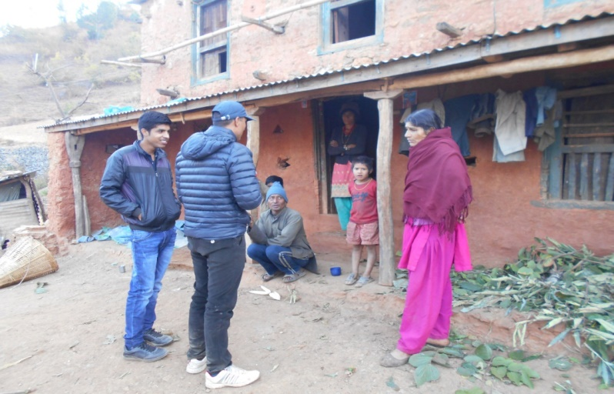
4.0 Understanding the Problem
In most rural districts of Nepal, there are hardly any rehabilitation or schooling opportunities for the blind, this is due to the fact that many areas are inaccessible. Many areas, especially in my district, are not connected by road.
Families who have blind children are often poor and uneducated. Most are not aware of the fact that blind children can learn how to walk, even in challenging landscapes. Many have never learnt about Braille and computers with speech synthesizers. Additionally, the local government has not conducted policies to assist these poor families with blind children.
My target community is situated in very remote parts of Nepal, which is economically and socially backward. Most of the families are marginalized and dominated by the privileged people.

Convincing to parents in remote area
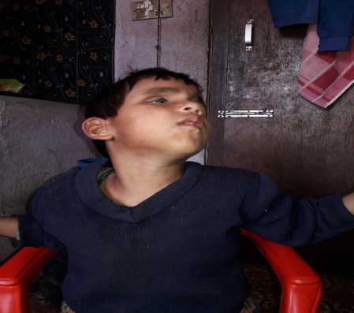
Blind children mostly stay alone at home while their parents are at work in the fields.
Causes of blindness are lack of proper health services during pregnancy, lack of eye care and incorrect medication. Due to poverty, people are uneducated and believe in superstition. Therefore sick children are treated by healers and witch doctors that often cause even more problems. Disasters, accidents and diseases are major causes of blindness.
According to the Nepal Blind Association survey, and Census 2011, more than 2500 blind children do not still have access of very basic needs and basic education. Moreover, Due to the 2015 earthquake, more than 150 children became blind and many children have lost their houses, parents and properties. This resulted in diseases, unhygienic conditions, loneliness, depression and frustration. One of the big problems is a misconceived attitude of community members and parents also, towards blind people and their abilities. Hence, those blind people, who have never been trained to walk independently, relied on sighted community members or were left back in their huts which endangered their lives. Dirt: lack of proper hygiene education (for example, not washing hands) and lack of sanitation and toilet training result in diseases. Death: Neglect by society, daily danger and diseases can lead to early death.

There is only one high school in Dhulikhel that provides limited Braille education for 5 blind children annually. Even those blind students, who have completed their higher education, don’t have any extra skills to fulfil their basic needs in order to live an independent life. Kavre district is only one example. There are many more such realities hidden in different parts of Nepal.
Given the above circumstances, there is urgent need for a various life skills approach. To ensure social participation we need to include the community, parents, school administration, local organizations and the government. Additionally, there is a need for accessible infrastructure, adequate facilities and related policy changes. Lastly, training in nutrition, mobility skills, and general life skills for the blind are critical.

5.0 Vision and Mission Statement

Vision
We see our Nepali blind children proudly walking with white canes, dress colorfully with big smiles.

Mission
We change the lives of our blind children by enhancing their skills through international qualitative training.
Principal objective:
REAL Nepal envisages that Nepal which is known for successful inclusion and integration of children with blindness into mainstream education and ultimately they are actively and meaningfully participated in all sectors of society with high position and respectful life without pity and charity.
Major Goal:
Our Initiative: To provide an international level quality education and useful lifeskill trainings with residential facility and to increase creative and dynamic competitor to fight meaningful employment for their future independence for Nepalese unreached blind children from rural and remote areas. This will help them transform being a rural child to becoming a global traveller.

5.1 Understanding How We Can Change Nepal
To further change these and many more lives, we enhance their skills through adequate quality training.

To prepare the school as it is now, REAL-Nepal started its actions by going on field trips to conduct a survey in all parts of Kavre district and other parts of Nepal. Once we convinced the parents and their children, we were able to involve the general community through gatherings. We talked to administrators and teachers of mainstream schools, and we negotiated with local policy makers and disability related organizations. Due to this process, all stakeholders; parents, donors, supporters and the blind themselves are aware of our activities.
In the second phase, we completed the initial setup of: “REAL Dream Home” which is a Residential educational training centre/Preparatory school for blind children.

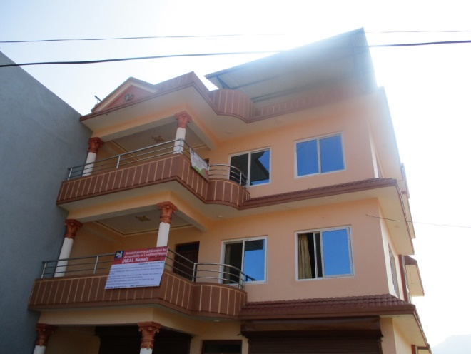
We chose for a residential set-up because many of these children come from far distances and need to walk for hours daily to reach our home. The school, which prepares children to go to mainstream school later, is located at Panauti Municipality ward No 4, Kavrepalanchowk, Nepal.
We started our educational training program on 15th December, 2017. Currently this home accommodates 15 blind children who are from different rural parts of Nepal.

We provide training in the following areas:

• Mobility and orientation skills (proper use of white cane),
• Braille literacy in Nepali and English language
• Dress maintenance,
• Health and sanitation,
• Basic skill of washing, cleaning and cooking
• Music and sports
• Computer skill with screen reader software (JAWS or NBDA or Google TTS )
• Dancing and singing in the stage
• Acting in theatre
• Communication skill and
• Recreational activities (Story-telling, speech and debate etc).

The general skills training is aimed to empower talented blind children regularly. It will support their independence in regular schools and it will later prepare them for professions like: school teacher, computer trainer, receptionist, computer operator, translator, counsellor, politician, singer, music teacher, musician, dancer, actor and international level player. As a long term solution, we will coordinate with responsible bodies for community based eye camps and we will promote school eye-health programs within main stream schools.

6.0 Project Sustainability:
Our mission: We change the lives of our blind children by enhancing their skills through international qualitative training. This is not possible within a year to change the vulnerable blind children to transform into a normal competitive youth. Therefore we are developing a sustainable plan for their sustainability forever. Some of the strategically plan could be applicable for long-term project sustainability, which are pointed below.
- Regarding the project sustainability we will submit the children’s document to the Nepal government education department for monthly scholarship for the inclusive education within project duration
- We will highly collaborate and coordinate with local community and local government for working together and helping each other. That could be a supporting part for the sustainable work.
- International relation with international grant making agency for regular funding according to the project nature through regular communication and proposal submission etc.
- To post the urgent needs, challenges and annual action plan in the social media and official sites of our organization for request to funding support.
- Request to the previous donors for second more time funding to long-term regularity of the project with analysis of the previous initial work, which we have done. If we succeed to become your regular grantee, we will highly request and encourage to be long-life potential donor. But this will totally depend on our project implementation system such as, frequently communication during the project running time, finance management, reporting, responsibility, reliability, accountability and transparency etc.

Key Needs for extreme sustainability
#. Scholarship for the 15 kids for at least initial 5 years
#. Our own rent-free training centre or school compound
#. Fund for two years for field visit to find the more vulnerable blind children around remote hilly regions of Nepal
#. Installation of the whole necessary structures like; small braille library, computer library, Audio library, music section, play ground and theatre, braille printing press etc.
#. Regular potential donor to arrange the very basic daily needs.

Monitoring and evaluation
The REAL-Nepal board will monitor the progress every half year. Once every 3 months, we offer an evaluation form to Parents of our students to track their progress. Additionally, we open our doors for regular visits of local community members, donors, well-wishers, supporter, local governmental representatives, and for the social welfare council.

7.0 REAL Dream Home Children Program

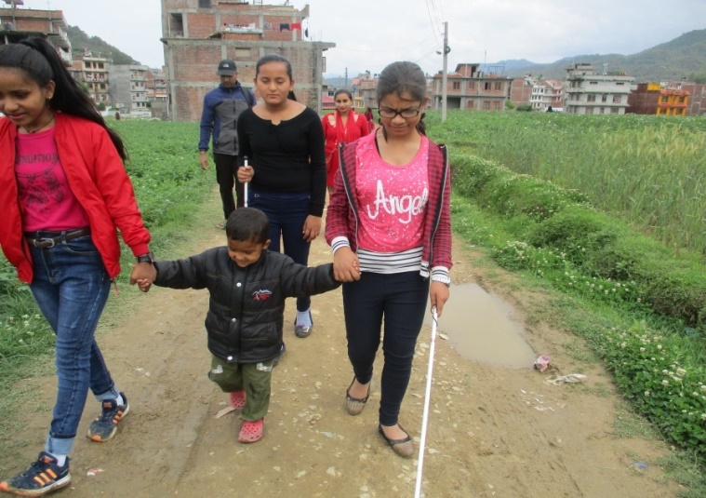
m
Project for Computer library and music class.
REAL Nepal is a social organization to provide educational training/preparatory schooling for the under privileged Nepalese blind children. We started our service on December 15, 2017 for 15 children, aged 5 to 15. Through our training program, most of the accommodated children are able to walk with their white canes and, ?they are able to read and write in Braille.

From the new session of May 2018, we felt that now it is time to send them to a mainstream school. Accordingly, in the morning, they go in a nearby government mainstream school (Shree Indreswor Higher secondary school Panauti, Kavrepalanchowk) together with their sighted peers. In the afternoons they return to the REAL dream home to receive mentorship and further training. In this way, we can guarantee a smooth process of integration.
Now children are completely enrolled in the classroom to start their mainstream education. Along with the inclusive regular education, we would like to provide additional skills through difference trainings regarding the world education system for BVI children. Therefore, from the year of 2019, we want to install a computer library to teach the basic computer knowledge and start the music class formally. So here we require grant US$ 26688.19
. to equips the computers and assistive devices, braille materials, music instruments,, daily living needs for 15 children, salary for special teacher and caregivers, and other involved educational materials. Please see the following detail budget table.

7.1 Expected Outcomes of the project:
• This residential training prepares the students in reading and writing in English and Nepali Braille, white cane usage, daily living skills, social skills and personal hygiene. The regular contact with other visually impaired children will show the students that they are not alone with their problems and they can build their confidence together.

•Through the computer and music training, within six month children will be able to use computer them self for typing and reading according to their needs. Also we will see them perfectly play the music instruments with practice children songs national anthem and with their own choice.
•This computer library always help them for their regular study because lack of enough braille books, blind students getting use the very limited course books. So all most school level text books are recorded by relevant organizations. Through use the devices in the computer and audio reader devices children can listen books and write in the braille. Therefore, the computer training is the needs of modern time to change the life of blind children.
•having our regular basic educational training program , children are enrolling in the regular classroom in the mainstream inclusive school. Who are able to read, write and walk independently. Even after joining the regular schools, the children are continuously living in our training centre because they are from rural, far-off places and there are no boarding facilities for blind children in schools as of now.
• Through mainstream schooling, blind and sighted children can learn together, exchange different experiences, and our blind children become confident in face-to-face conversations with mainstream class/grade teachers and sighted mates.
• Our blind children will enrol in the national curriculum and teaching-learning methodology. The parallel teaching in regular classes and specific REAL Nepal classes will ensure good results in school.

7.2 Budget
The detail estimated budget description is presented below.

Currency exchange US$ | 113.82 | 15/03/2019 | Nepal Rastra Bank
S.N | Item description | Unit | Frequency | Unit cost | Unit cost | Total cost | Total Cost | category
 |  |  |  | NPR | US$ | NPR | US$
1 | Home rent | 1 | 12 | 25000 | 219.6451 | 300000 | 2635.741 | Running cost
2 | Braille paper (Rim) | 4 | 12 | 1050 | 9.225092 | 50400 | 442.8044 | Running cost
3 | Braille slates stailas sets | 20 | 2 | 1500 | 13.1787 | 60000 | 527.1481 | Running cost
4 | White canes | 20 | 2 | 1000 | 8.785802 | 40000 | 351.4321 | Running cost
5 | Braille letter initiative books | 15 | 2 | 2000 | 17.5716 | 60000 | 527.1481 | Running cost
6 | Other braille assistive devices sets | 15 | 2 | 2500 | 21.96451 | 75000 | 658.9352 | Running cost
7 | Musical instruments | 1 | 1 | 190000 | 1669.302 | 190000 | 1669.302 | onetime cost
8 | Food accommodation | 15 | 365 | 150 | 1.31787 | 821250 | 7215.34 | Running cost
9 | computer with screen reader software | 8 | 1 | 50000 | 439.2901 | 400000 | 3514.321 | onetime cost
10 | Audio books reader with hard drive | 15 | 1 | 3000 | 26.35741 | 45000 | 395.3611 | onetime cost
11 | Sound system for recreational activities | 1 | 1 | 40000 | 351.4321 | 40000 | 351.4321 | onetime cost
12 | Educational tour | 18 | 3 | 2000 | 17.5716 | 108000 | 948.8666 | Running cost
13 | Teacher salary | 1 | 12 | 15000 | 131.787 | 180000 | 1581.444 | Running cost
14 | Caregivers salary | 2 | 12 | 12000 | 105.4296 | 288000 | 2530.311 | Running cost
15 | Multiplug | 5 | 1 | 1800 | 15.81444 | 9000 | 79.07222 | onetime cost
16 | Computer table and chairs | 8 | 1 | 15000 | 131.787 | 120000 | 1054.296 | onetime cost
17 | Emergency medical box | 1 | 2 | 10000 | 87.85802 | 20000 | 175.716 | Running cost
18 | Head sets | 8 | 1 | 2000 | 17.5716 | 16000 | 140.5728 | onetime cost
19 | two sets school uniform | 15 | 1 | 10000 | 87.85802 | 150000 | 1317.87 | onetime cost
20 | Medium voltage UPS for backup | 1 | 1 | 65000 | 571.0771 | 65000 | 571.0771 | onetime cost
 | Grand total |  |  | 449000 | 3944.825 | 3037650 | 26688.19 |  | /

Curriculum Modality:
Venue: REAL Nepal (REAL Dream Home), a residential educational training centre/Preparatory school.
This curriculum is a preparatory and a supplementary course for blind and visually impaired children. The preparatory course is for children who have not been to school yet, so they need to learn to read and write. The supplementary course is for school going children who already read and write print, but later became blind by Nepal earthquake of 2015 or other unfortunate accidents. And this course also addresses to those children who are partially sighted. The curriculum contains skills or capacities that students should acquire during the training and suggestions for methods and activities to practice these skills and capacities. Of course this list is not complete; many more activities need to be added. In general, it is advisable to choose teaching methods that allow active participation of the children and challenge them to use different learning channels. This helps to memorize contents for children who are audible or haptic learners. Compared to memorizing of contents, the playful use, own reconstruction or discovery during field trips will increase the possibility to remember content and apply it later.

Some of the contents of this curriculum are applicable for preschool as well as for school going children before they become blind. Children who have not been to school but are older than preschoolage, might already be able to manage their daily activities, but need a complete literacy program. The same, totally blind children don't need visual stimulation, but they might need more time for mobility or daily living skills.

Once children complete the training, they come back to the centre for regular follow up meetings. These can take place during a weekend or when work in school is not so intensive. The meetings are an opportunity to exchange experience, discuss good methods to solve certain problems such as getting help for reading or social integration. As young children only learned Nepali Braille during the preparatory course, they will learn the English alphabet during the follow up meetings. If possible, a science teacher helps children to understand the contents of school with the help of adaptive material. Games help the children to socialize and relax and collect strength to sustain the struggle for integration.

Curriculum Methodology:

Sensory Stimulation

Category | Contents |  | Methods/activities
 | Preparatory Course | Supplementary Course | Preparatory Course | Supplementary Course
Functional vision | Assessment of functional vision for use in different situations and under different conditions |  | Assessment of visual behaviour in different situations (inside - outside, familiar – non familiar surrounding) and under different conditions (day – night, sun light – artificial light, colours – black and white)
Concepts | Understand concepts (colours, shapes, size, directions, etc.) |  | Sort/categorize objects, follow directions (left, right),
Explore the surrounding | Know objects in the familiar surrounding |  | Explore kitchen tools, parts of the house, etc. use models of houses, trees.
Visual stimulation | How to use the remaining vision effectively |  | Experiment with light, contrast, colours, sizes, distance. Practice drawing, identification of colours and objects, visual clues for orientation, etc. If available, find useful visual aids.
Stimulation of other senses | Identify objects by sound, smell, taste. Interpretation of sensual information |  | Blind folded activities: touch different materials and describe how they feel, listen to noises of the surrounding, games to recognize smell or taste, identify direction of a sound, analyse the information: smell of a shop, sound of early morning, etc.
Practice of learning channels | Listening skills, understand visual and tactile information. |  | Listen to stories/radio plays and give a short summary.  Understand models; find relevant information by touch or vision. | Listen to stories/radio plays and take notes, understand models, maps, and simple graphics in tactile or visual format.

Reading and writing
Category | Contents |  | Methods/activities
 | Preparatory course | Supplementary course | Preparatory course | Supplementary course
Pre reading skills | Recognize combinations of dots, connect shapes to letters, playful approach to reading | Connect shapes to letters, recognize combination of dots, increase sensitivity of finger tips | Play with coloured print letters or coloured balls for Braille, feel Braille and describe shapes. | Feel Braille and describe shapes, form letters with coloured balls.
Pre writing | Learn the use of slate and stylus (position of dots), practice the use of pens |  | Play with slate and stylus, draw shapes in Braille, draw with colours.
Braille reading and writing | Understand the concept of letters and words; write the name, simple words and sentences. | Learn Nepali and English alphabet, read and write in good speed. | Use coloured balls for reading, each dot one colour, this gives a visual learning channel to remember letters. Braille as a secret writing, write Braille letters, pass messages, etc.
Print reading and writing | Basic knowledge of the print alphabet | Find best method to read and write print | Use big print letters to form words, use big pens for writing. | Experiment with different pens, colours, sizes etc. for best visibility.

General Knowledge
Category | Contents |  | Methods/activities
 | Preparatory course | Supplementary course | Preparatory course | Supplementary course
English. | Playful English for first contact | English communication | English songs, poems, games to lose shyness of speaking English. | English communication as an additional skill to give in exchange to help at school
Maths | Numbers, counting, geometric shapes. adding, subtracting | Find adequate method for math; help to fill gaps resulting from missing support at school. | Count objects, simple additions and subtractions, recognize and draw simple geometric shapes. | Mathematic Braille magnified print, geometric shapes, etc. to find effective learning methods.
Geography | Dhulikhel, Banepa, Panauti, their villages, mountains, rivers. | Kavre, Nepal. Continent, Asia | Use models or simple maps, go on field trip to see rocks, mountains, etc. | Use tactile or coloured maps to show what might not be understood at school
Plants and animals | Recognize local plants and animals |  | Touch chicken, mules, trees, etc.
Science | Observe daily phenomena and find explanations. | Understand more complex facts with help of adaptive material | Observe snow, water when freezing or evaporating, growing of plants, etc. | Use models, coloured or tactile graphics or other material to understand facts that were explained at school.

Independence and Integration
Category | Contents |  | Methods/activities
 | Preparatory course | Supplementary course | Preparatory Course | Supplementary course
Creative expression | To boost creativity, increase self-confidence and free expression in public. |  | Music, dance, drama, etc.
Cultural events | Integration in the community, understanding of local culture and traditions. |  | Participate in local festivals, activities of other schools etc., if possible with performances.
Motor skills | Lose fear of independent movement, improve motor skills |  | Physical activities (running, jumping, climbing, walking, horse riding, swimming, games).
Integration | Find games that can be played with sighted children |  | Adaptation of regular school games (ball wrapped in plastic back, bells to identify the person to catch, blind folding other children, etc.)
Mobility | Movement in familiar surroundings, use of a sighted guide and a cane if necessary, use of vision and other senses for orientation, orientation at night or when vision is not as good. | Move independently in familiar and non-familiar surroundings; use a white cane where necessary. Walk suavely in remote areas and use all senses to identify obstacles and points of reference. Find techniques for orientation when vision is not as good. | Find points of reference in house and surrounding, use light, smells, different sounds for orientation. Practice walking with siblings or friends. If necessary, use a cane outside the house. Blind fold to practice movement at night. | Find points of reference in the village, practice walking up and down hill on rocky path, use all senses to avoid obstacles and travel safely. Blind fold to improve other senses and practice use of a cane. Find techniques for situations when vision is not as good.
Daily living skills | Independent eating, drinking, clothing, use of the bathroom, etc. Small housework’s such as setting the table, organizing clothes, etc. | Daily routine for most independence possible, explain also to parents to continue practice during visits at home. | All necessary housework such as washing clothes, washing dishes, preparing food, cleaning, etc. Continue practice at home. | Daily routine while helping with housework, the same tasks for boys and girls.

Language and Communication
Category | Contents |  | Methods/activities
 | Preparatory course | Supplementary course | Preparatory course | Supplementary course
Communication | Communicate confidently, start a conversation and ask questions, use appropriate language. |  | Practice communication in the group and with adults. Use polite language (please, thank you).
Language | Increase vocabulary and correct use of language. |  | Storytelling, description of objects, situations, feelings.
Gesture | Use gestures appropriately. Reduce inappropriate behaviour (body movements, holding head down, etc.) |  | Daily routines, practice gestures in role plays, touch adults while talking to understand position of head, etc.

Values and Group Process
Category | Contents |  | Methods/activities
 | Preparatory course | Supplementary course | Preparatory course | Supplementary course
Decision making and problem solving | Make democratic decisions about issues, activities, rules. Discuss problems and find solutions together. |  | Regular discussions about current issues, the programme for the week, rules, etc.
Critical thinking | Question statements and rules; ask for reasons to accept something. Logical/independent thinking instead of following blindly. |  | Always give explanations why certain rules are important. Give reason why to learn, do or not do something. Start discussions about actions or opinions of children, ask for explanations.
Social behaviour | Show respect for members of the group: stay in queue; wait for turn to talk, etc. |  | Daily routine with rules agreed on together with children.
Values | Tolerance, mutual respect, punctuality, reliability, open communication, etc. |  | Act as example for those values, include them in rules made in the group in a child friendly way. Discuss why they are important and what happens if they are not respected.

9.0 Key terminology
- Braille:
Braille is a system of making raised dots on paper to form letters and words that are read by the blind with their fingertips. The basic Braille 'cell' consists of two columns of three dots. The dots are numbered 1-2-3 from top to bottom on the left side of the cell and 4-5-6 from top to bottom on the right side of the cell. Each Braille letter, word, punctuation mark, number, or musical note can be made up using different combinations of these dots.

- Whitecane:
A white cane is used by many people who are blind or visually impaired. Primarily it aids its user to scan their surroundings for obstacles or orientation marks, but is also helpful for other traffic participants in identifying the user as blind or visually impaired and taking appropriate care.

- Speech Synthesizer:
Speech Synthesizer is a screen reader software to read the computer screen with voice, such as: JAWS, NVDA and Google TTS etc. This is only one way to operate the computer or electrical devices for blind and visually impaired user.

- Rehabilitation:
Rehabilitation is a process aimed at enabling differently challenging people to reach and maintain their optimal physical, sensory, intellectual, psychological and social functional levels: “World Health Organization (WHO)”
And enhancing them through additional assisting devices to provide them effective needs for their successful independent life like others mainstream people.

- Creating awareness:
Inform the community, parents and family members, teachers of mainstream schools, local organizations and governmental officials about the possibilities of blind people through meetings, real life examples, rallies, trainings and by the media.

- Integration:
Bring together all types of people in the same society for equally treat and develop their lives with equal opportunity.

